**RDS Database Creation**

***Here you will learn how to create a new database usind RDS***

*Follow the given steps*

1. First open aws console.
2. Click on RDS service

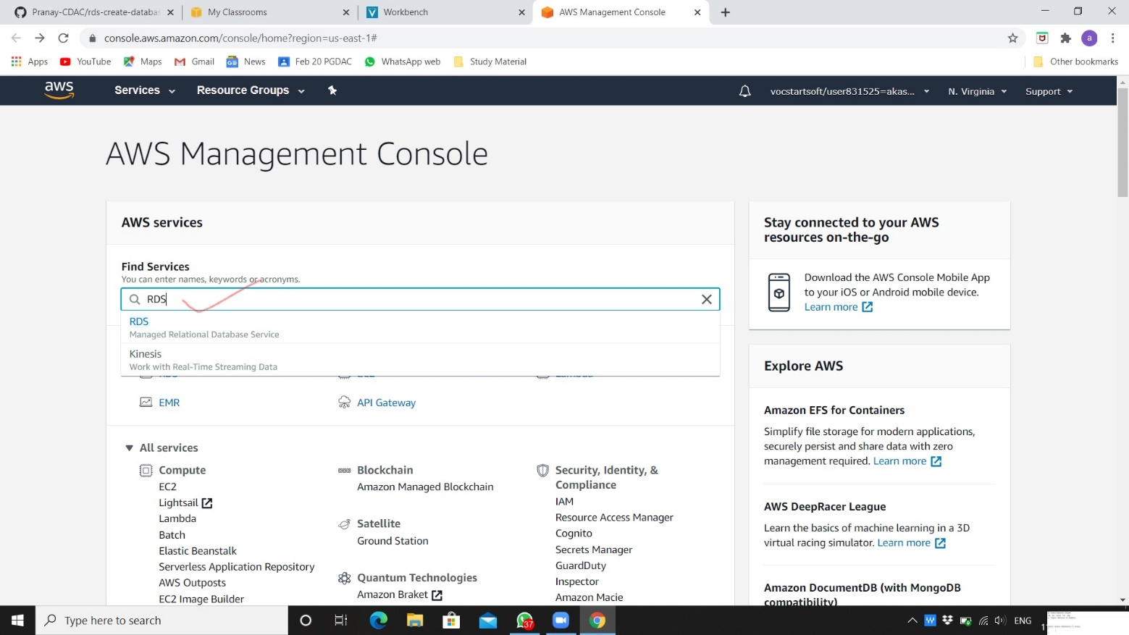

1. Click on create database.

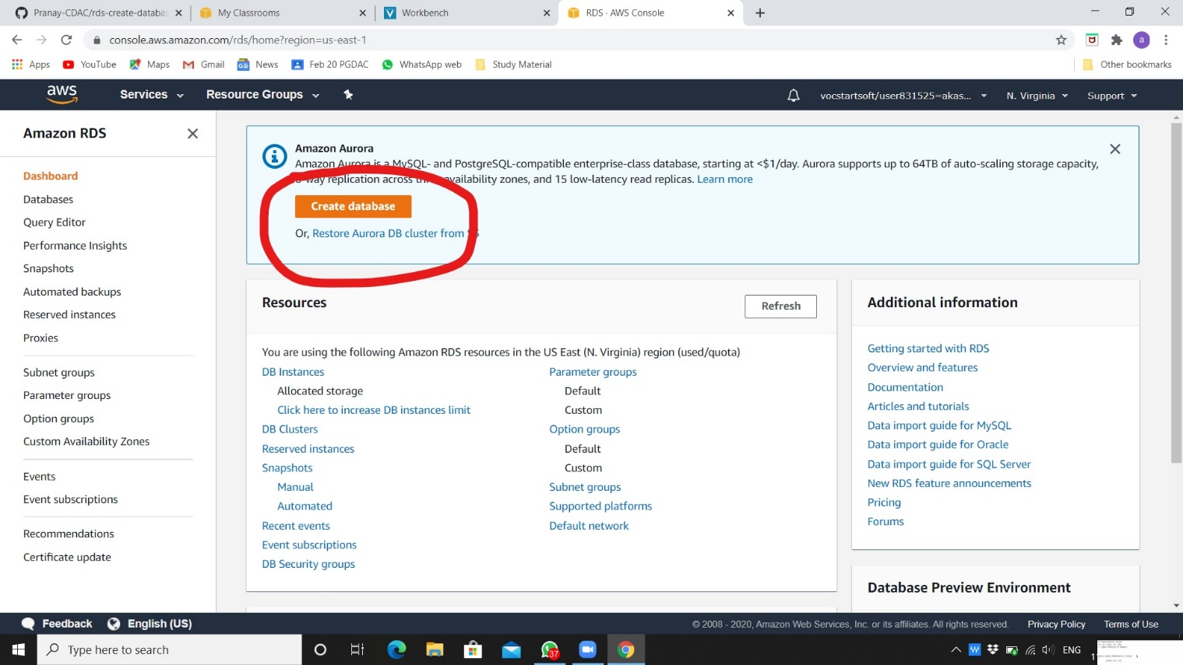

1. Choose options like below image for creating database.

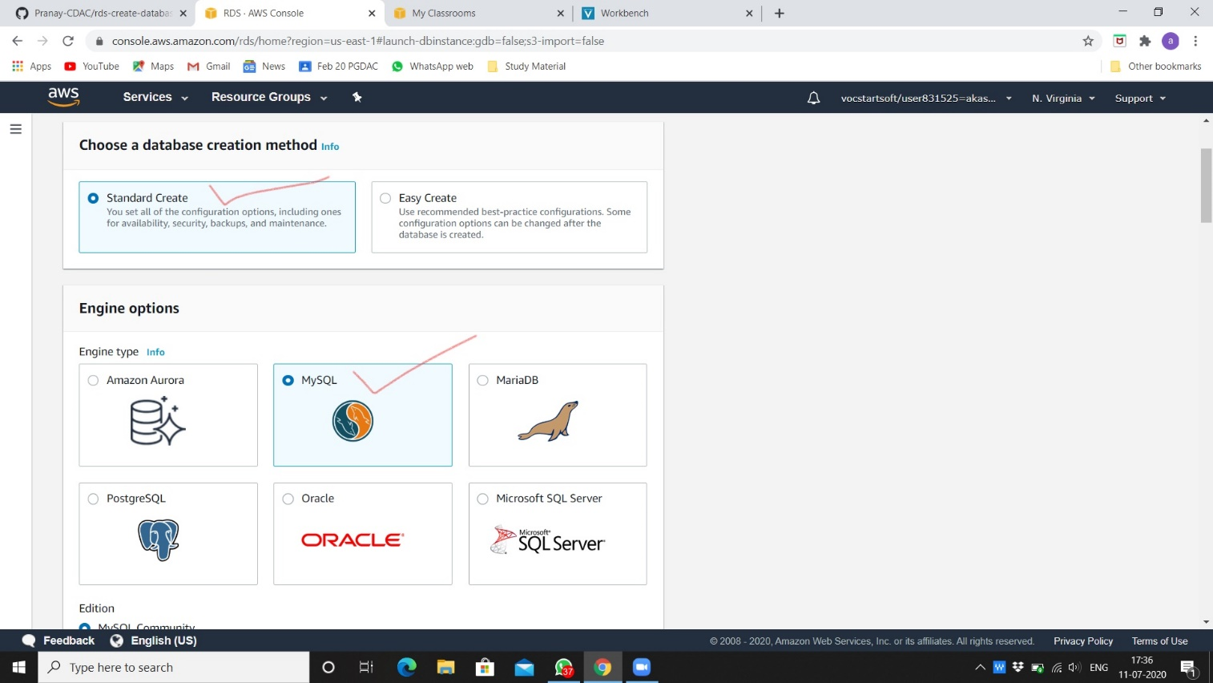

1. Choose version and templates.

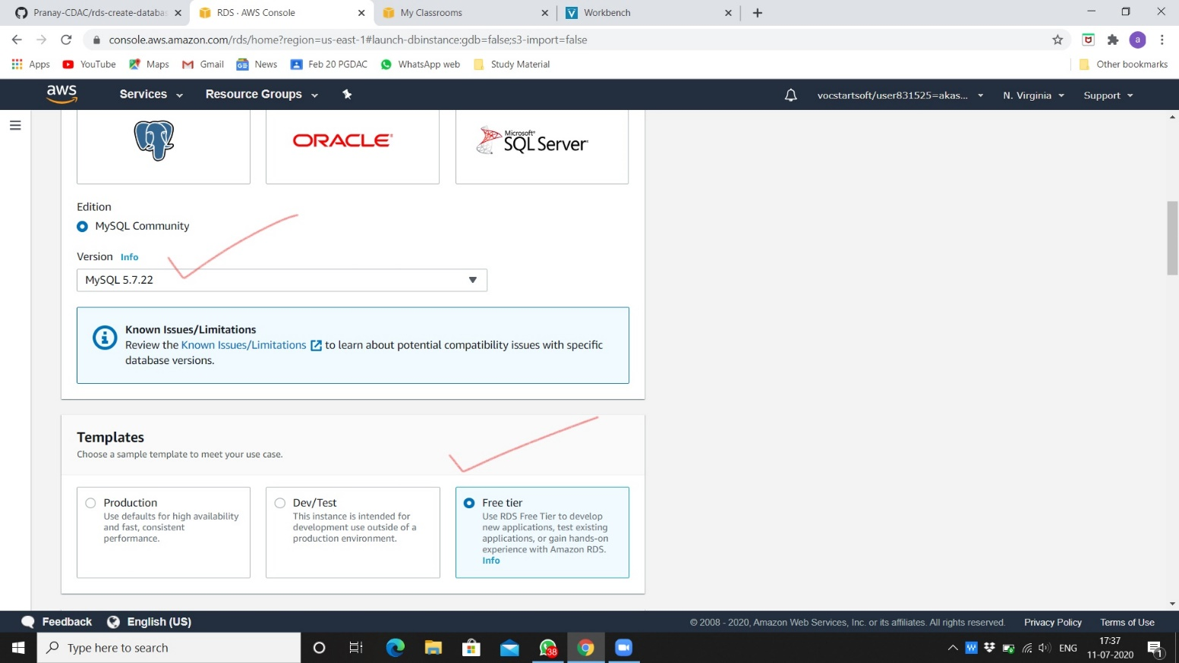

1. Choose all options from settings and fill accordingly.

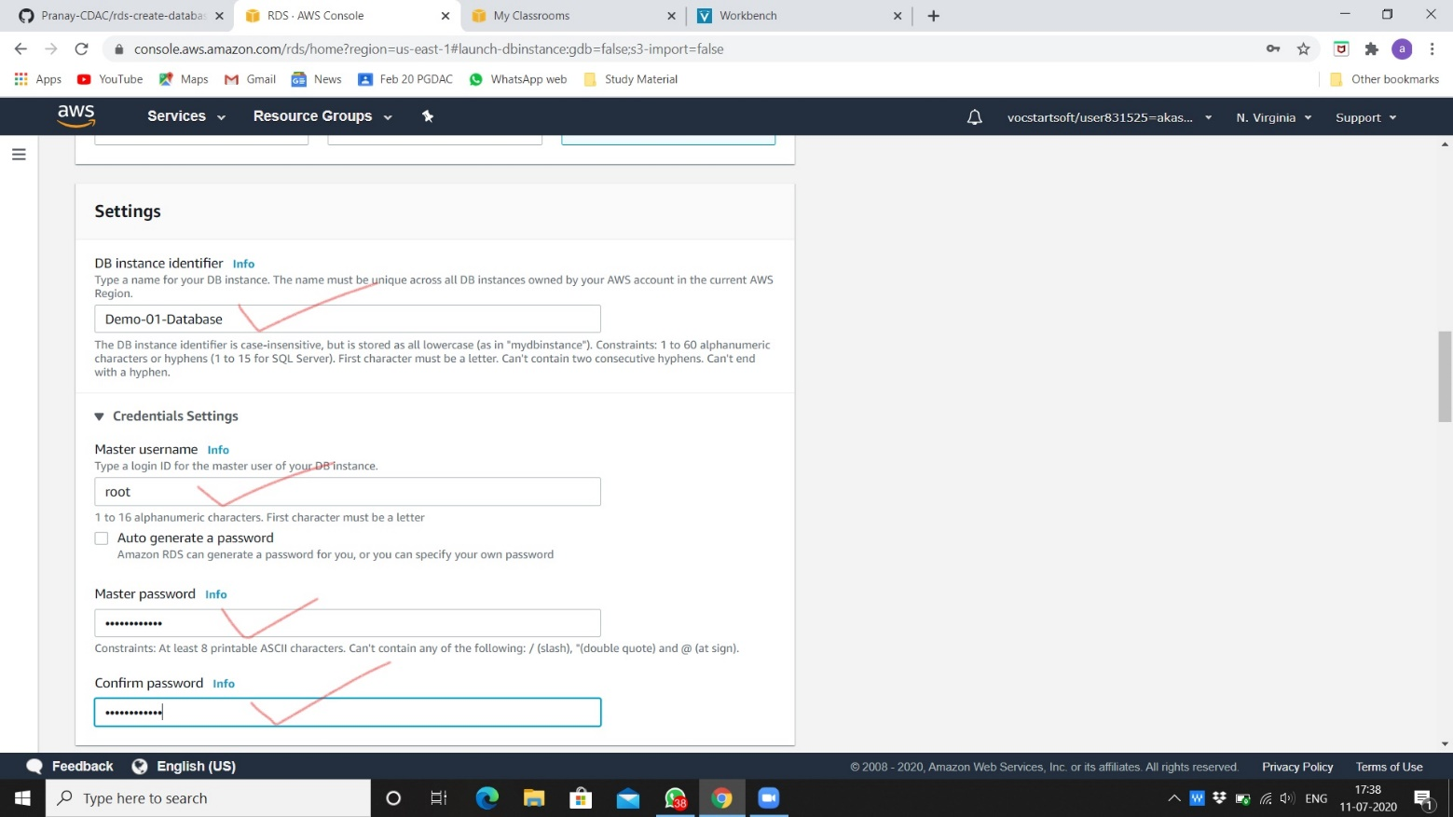

1. Fill storage options accordingly.

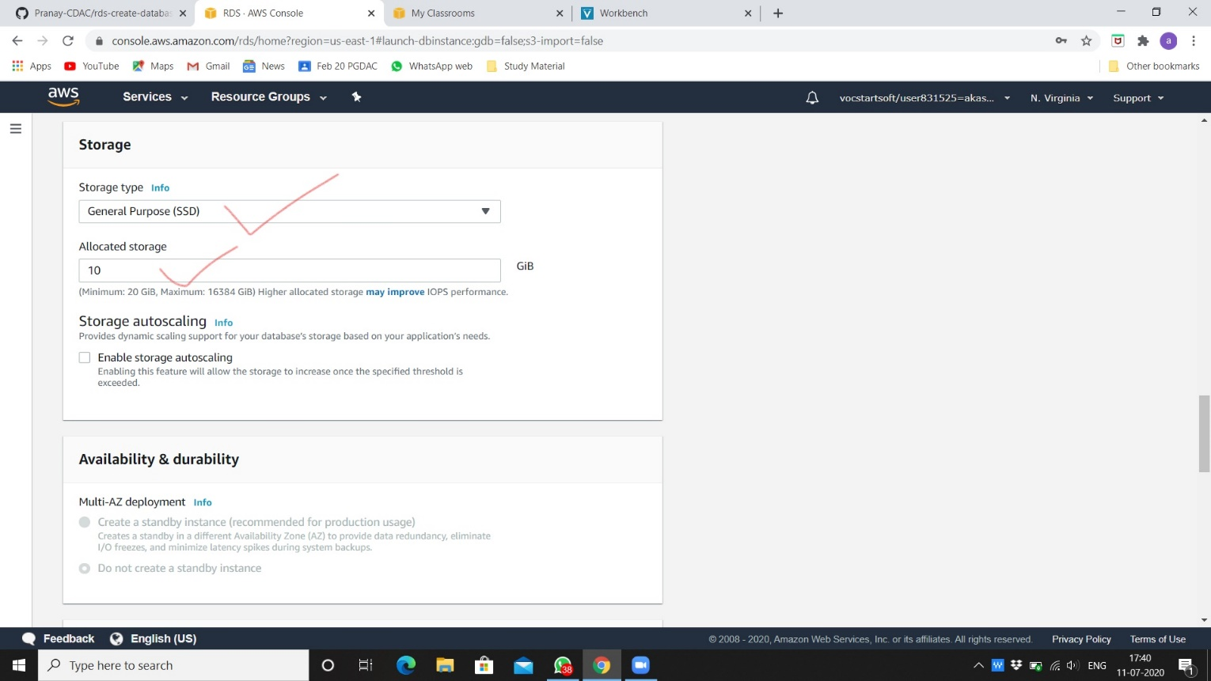

1. Do connectivity.

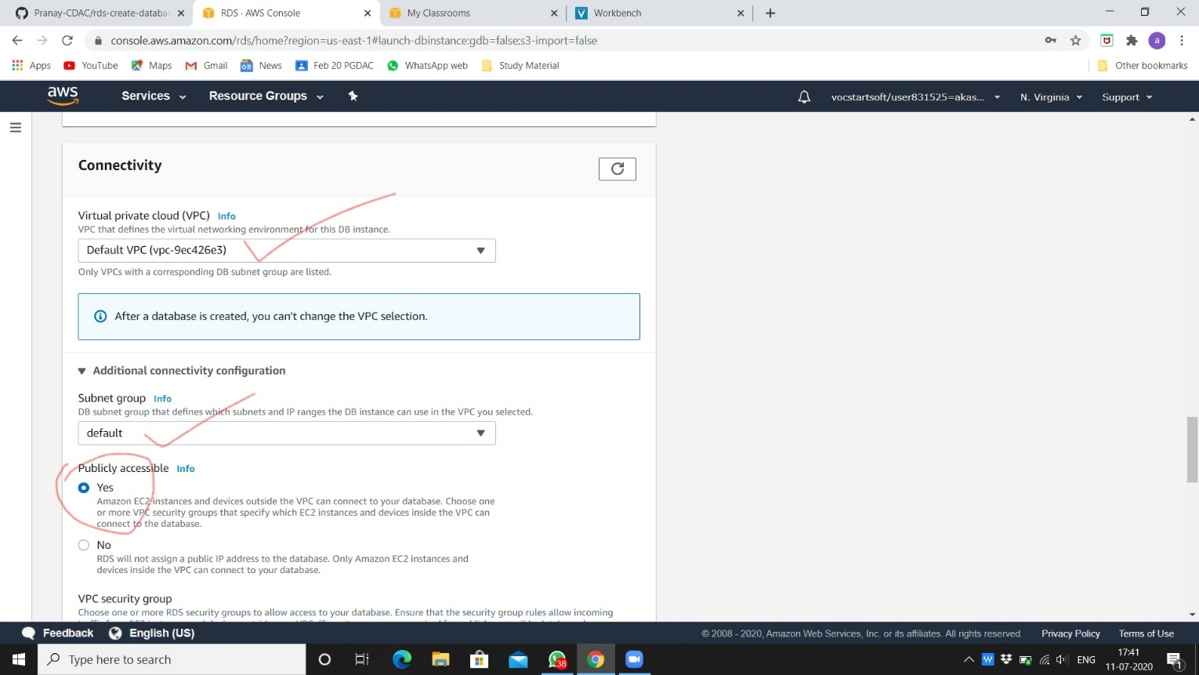

1. After done with all options, click on create database.

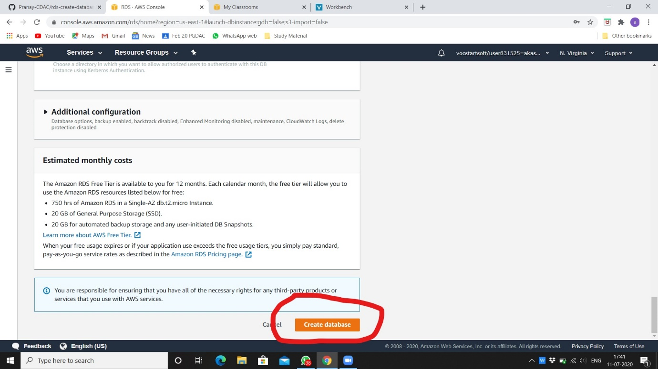

1. You can see database is created successfully for use.

